**Experiment-1.1**

**Aim of the Experiment :** Accessing the colored/grayscale image/video elements

1. Accessing the colored/grayscale image elements.
2. Accessing the video elements choosing random frame and greyscale it.
3. Accessing the colored/grayscale image elements.

**Problem Description :**

An RGB image can be viewed as three images ( a red scale image, a green scale image and a blue scale image) stacked on top of each other. In MATLAB, an RGB image is basically a M*N*3 array of colour pixel, where each colour pixel is a triplet which corresponds to red, blue and green colour component of RGB image at a specified spatial location.

A Grayscale image can be viewed as a single layered image. In MATLAB, a grayscale image is basically M*N array whose values have been scaled to represent intensities.

In MATLAB, there is a function called rgb2gray() is available to convert RGB image to grayscale image. Here we are using **(R * 0.2989) + (G * 0.5870) + (B * 0.114)**

**Code for Experiment :**

**For image element :-**

coloredImage = imread('C:/Users/milan/Downloads/lena_color.jpg');

R=coloredImage(:, :, 1);

G=coloredImage(:, :, 2);

B=coloredImage(:, :, 3);

gray_img=(R*0.2989)+(G*0.5870)+(B*0.114);

gray_img1=(R*0.122)+(G*0.5870)+(B*0.114);

gray_img2=(R*0.2989)+(G*0.113)+(B*0.114);

gray_img3=(R*0.2989)+(G*0.5870)+(B*0.132);

subplot(3,3,1) ,imshow(coloredImage)

title("Original Image")

subplot(3,3,2) ,imshow(R)

title("R")

subplot(3,3,3) ,imshow(G)

title("G")

subplot(3,3,4) ,imshow(B)

title("B")

subplot(3,3,5) ,imshow(gray_img)

title('Standard Grayscale');

subplot(3,3,6) ,imshow(gray_img1)

title('Customized Grayscale 1');

subplot(3,3,7) ,imshow(gray_img2)

title('Customized Grayscale 2');

subplot(3,3,8) ,imshow(gray_img3)

title('Customized Grayscale 3');

rgbImage = cat(3, gray_img1, gray_img2, gray_img3);

subplot(3,3,9), imshow(rgbImage)

title("Combined Image")

sgtitle("Milan Sharma 23MAI10003")

**Result/Output :**

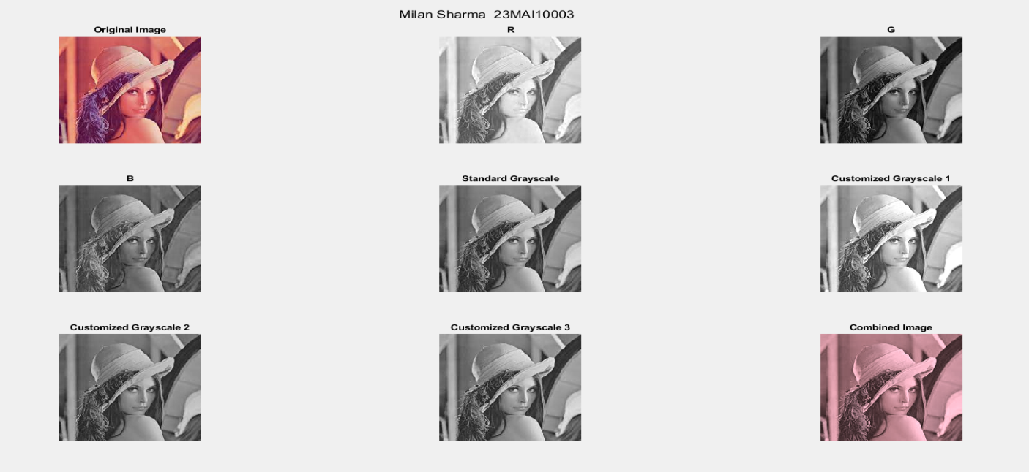

1. Accessing the video elements choosing random frame and greyscale it.

**Problem Description :**

The frame is a combination of the image and the time of the image when exposed to the view.

We can use the VideoReader class to set the starting time of the video, then use read() to extract a frame from the video at exactly that time. Then use imwrite() to save it to disk.

X = randi(1,___) generates numbers from random number stream s instead of the default global stream. To create a stream, use [RandStream](https://in.mathworks.com/help/matlab/ref/randstream.html). You can specify s followed by any of the input argument combinations in syntaxes.

randi([1,y]) generates a random number in between 1 and y. Then we can use this random number to access the random frame from the Video.

read(VideoObj,Rframe) function read the random frame from the Video.

**Code for Experiment :**

**For Video element :-**

videoObj = VideoReader('H:/Lively wallpaper/Minecraft.mp4');

frame=videoObj.NumFrames;

random_frame=randi([1,frame]);

X = ['Total Frames in Video : ',num2str(frame)];

Y = ['Random Frame selected : ',num2str(random_frame)];

output = read(videoObj, random_frame);

p1=output(:,:,1);

p2=output(:,:,2);

p3=output(:,:,3);

grey_vid=(0.299*p1)+(0.587*p2)+(0.114*p3);

grey_vid1=(0.120*p1)+(0.587*p2)+(0.114*p3);

grey_vid2=(0.299*p1)+(0.512*p2)+(0.114*p3);

grey_vid3=(0.299*p1)+(0.587*p2)+(0.10*p3);

subplot(2,4,1), imshow(output)

title('Orignal')

subplot(2,4,2), imshow(p1)

title('R')

subplot(2,4,3), imshow(p2)

title('G')

subplot(2,4,4), imshow(p3)

title('B')

subplot(2,4,5), imshow(grey_vid)

title('Standard grayscale')

subplot(2,4,6), imshow(grey_vid1)

title('Custom greyscale 1')

subplot(2,4,7), imshow(grey_vid2)

title('Custom greyscale 2')

subplot(2,4,8), imshow(grey_vid3)

title('Custom greyscale 3')

rgbImage = cat(3, grey_vid1, grey_vid2, grey_vid3);

subplot(3,3,9), imshow(rgbImage)

title("Combined Image")

sgtitle(["Milan Sharma 23MAI10003",X,Y])

**Result/Output :**

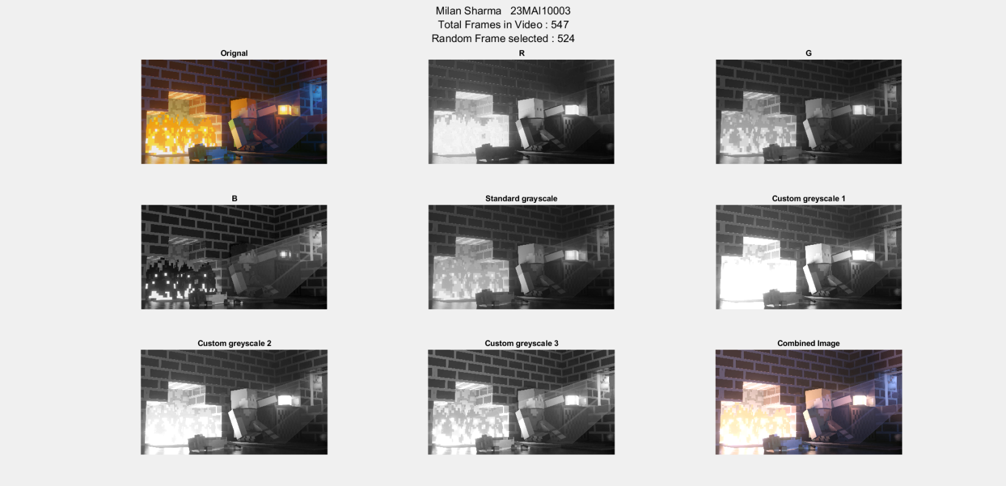

**Learning outcomes (What I have learnt):**

**1. Learned to convert an RGB image to Grayscale.**

**2. Learned to show random frame of a video.**

**3. Learned to perform basic function on images and videos**